1. Declare a single-dimensional array of 5 integers inside the main method. Traverse the array to print the default values. Then accept records from the user and print the updated values of the array.
2. **package** org.example;
3. **import** java.util.Scanner;
4. **public** **class** Array2 {
6. **public** **static** **void** acceptRecord(**int**[]arr ) {
7. Scanner sc =**new** Scanner(System.***in***);
8. System.***out***.println("Enter 5 array elements");
9. **for**(**int** i=0;i<arr.length;i++) {
10. System.***out***.println("Enter the elements"+" "+i+":");
11. arr[i]=sc.nextInt();
12. }
13. }
14. **public** **static** **void** printRecord(**int**[]arr ) {
15. System.***out***.println("Enter the elements:");
16. **for**(**int** i=0;i<arr.length;i++) {
17. System.***out***.println("arr+["+ i+"]= "+arr[i]);
19. }
20. }


24. **public** **static** **void** main(String[] args) {
25. **int**[] arr=**new** **int**[5];
27. System.***out***.println("Enter default values of array");
28. *printRecord*(arr);
30. *acceptRecord*(arr);
32. *printRecord*(arr);
33. }
34. }

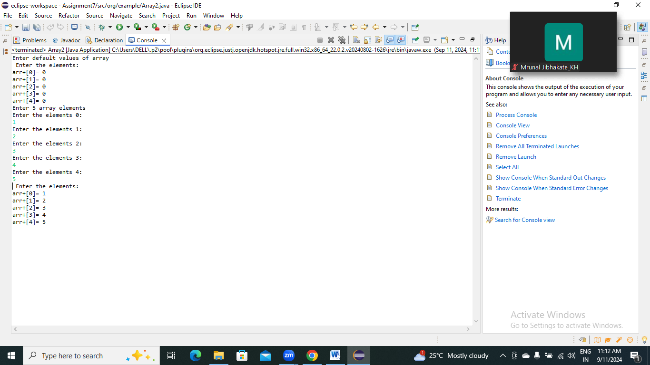

2.Declare a single-dimensional array of 5 integers inside the main method. Define a method named acceptRecord to get input from the terminal into the array and another method named printRecord to print the state of the array to the terminal.

**package** org.example;

1. **import** java.util.Scanner;
2. **public** **class** Array2_1 {
4. **public** **static** **void** acceptRecord(**int**[] arr) {
5. Scanner sc=**new** Scanner(System.***in***);
6. System.***out***.println("Enter 5 array elements");
7. **for**(**int** i=0;i<arr.length;i++) {
8. System.***out***.println("Enter Elements :"+ i+ ":");
9. arr[i]=sc.nextInt();
10. }
11. }
12. **public** **static** **void** printRecord(**int**[] arr) {
13. System.***out***.println("State of the array is:");
14. **for**(**int** i=0;i<arr.length;i++) {
15. System.***out***.println("arr ["+i+"]="+ arr[i]);
16. }
17. }

20. **public** **static** **void** main(String[] args) {
21. **int**[] arr= **new** **int**[5];

24. *printRecord*(arr);

27. *acceptRecord*(arr);
29. }
30. }

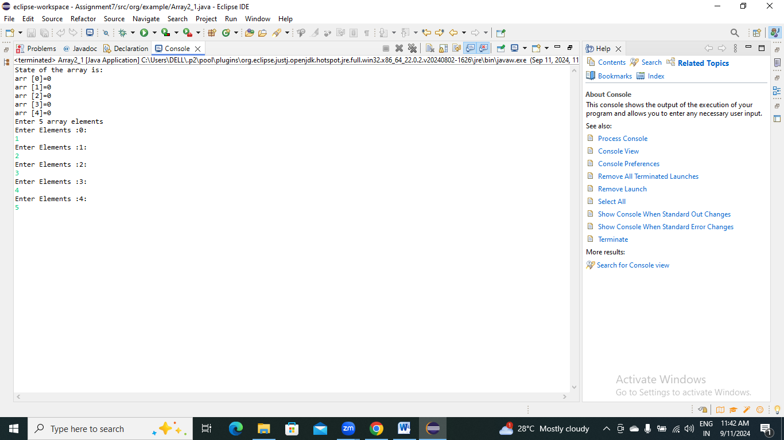

3.Write a program to find the maximum and minimum values in a single-dimensional array of integers.

1. **package** org.example;
2. **public** **class** Array3 {
4. **public** **static** **int** findMax(**int**[] arr) {
5. **int** max = arr[0];
6. **for** (**int** i = 1; i < arr.length; i++) {
7. **if** (arr[i] > max) {
8. max = arr[i];
9. }
10. }
11. **return** max;
12. }
14. **public** **static** **int** findMin(**int**[] arr) {
15. **int** min = arr[0];
16. **for** (**int** i = 1; i < arr.length; i++) {
17. **if** (arr[i] < min) {
18. min = arr[i];
19. }
20. }
21. **return** min;
22. }
23. **public** **static** **void** main(String[] args) {
25. **int**[] arr = {10, 20, 30, 40, 50};
27. **int** max = *findMax*(arr);
28. **int** min = *findMin*(arr);
30. System.***out***.println("Maximum value in the array: " + max);
31. System.***out***.println("Minimum value in the array: " + min);
32. }
33. }

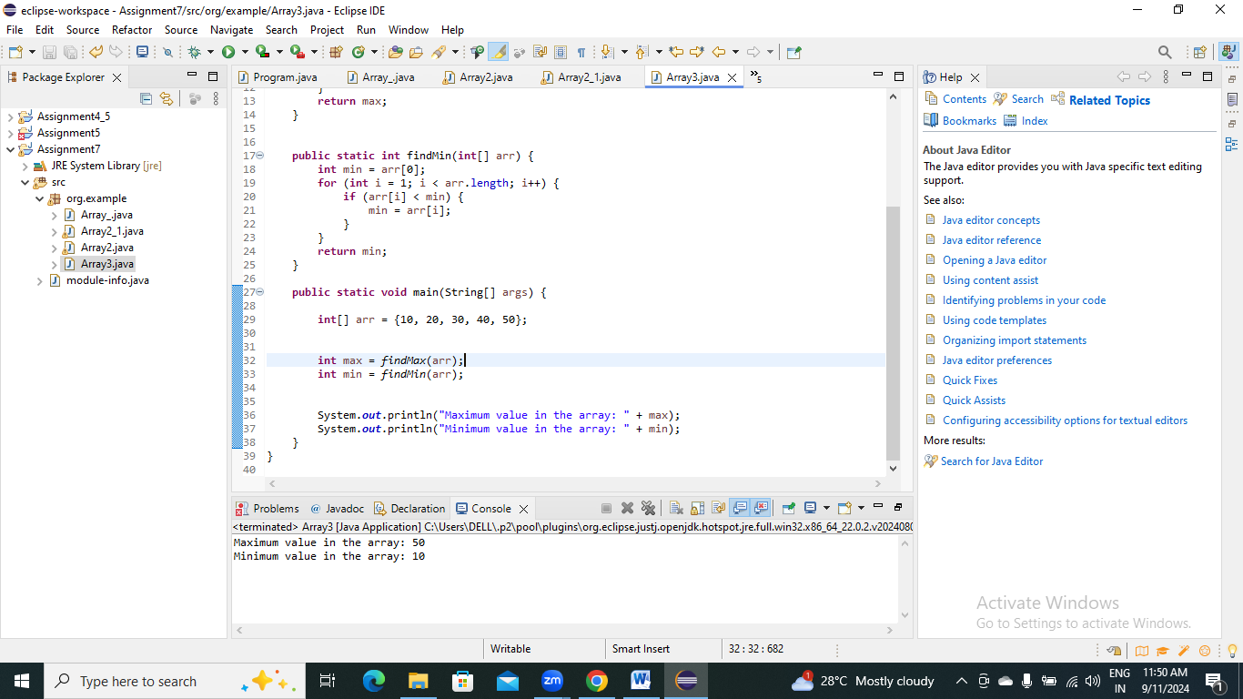

4.Write a program to remove duplicate elements from a single-dimensional array of integers.

**package** org.example;

**import** java.util.Arrays;

**public** **class** Array4 {

**public** **static** **int**[] Array4(**int**[] arr) {

Arrays.*sort*(arr);

**int**[] temp = **new** **int**[arr.length];

**int** j = 0;

**for** (**int** i = 0; i < arr.length - 1; i++) {

**if** (arr[i] != arr[i + 1]) {

temp[j++] = arr[i];

}

}

temp[j++] = arr[arr.length - 1];

**int**[] result = **new** **int**[j];

System.*arraycopy*(temp, 0, result, 0, j);

**return** result;

}

**public** **static** **void** main(String[] args) {

**int**[] arr = {10, 20, 30, 20, 40, 50, 10, 50};

**int**[] uniqueArr = *Array4*(arr);

System.***out***.println("Array after removing duplicates:");

**for** (**int** num : uniqueArr) {

System.***out***.print(num + " ");

}

}

}

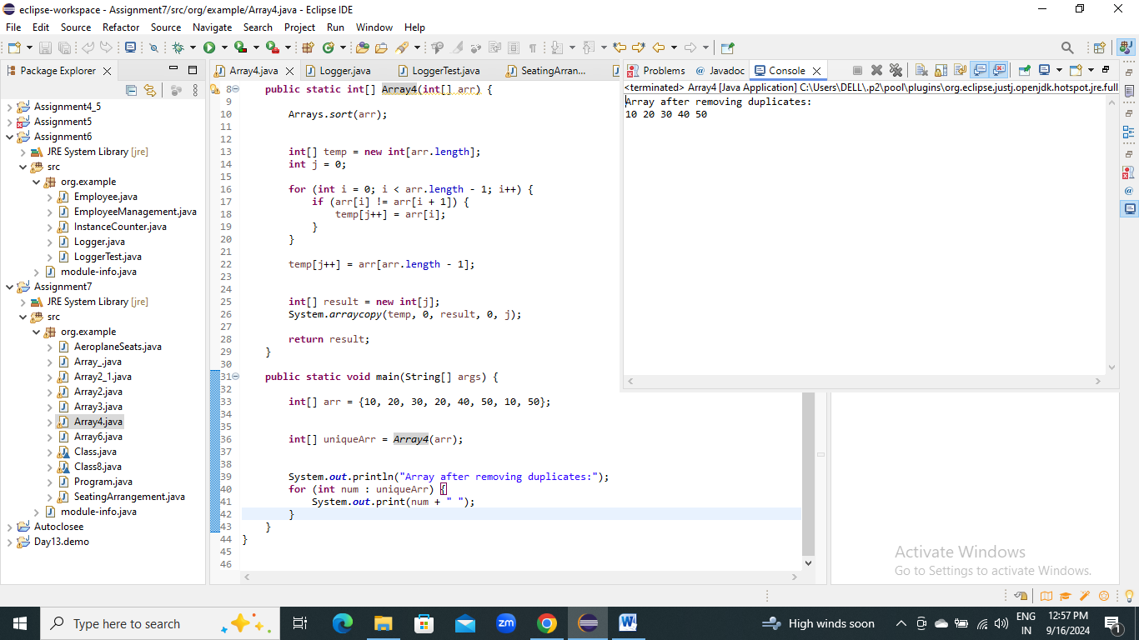

5.Write a program to find the intersection of two single-dimensional arrays.

**package** org.example;

**import** java.util.Scanner;

**public** **class** Array5 {

**public** **static** **void** main(String[] args) {

Scanner scanner = **new** Scanner(System.***in***);

System.***out***.print("Enter the number of elements in the first array: ");

**int** n1 = scanner.nextInt();

**int**[] array1 = **new** **int**[n1];

System.***out***.println("Enter the elements of the first array:");

**for** (**int** i = 0; i < n1; i++) {

array1[i] = scanner.nextInt();

}

System.***out***.print("Enter the number of elements in the second array: ");

**int** n2 = scanner.nextInt();

**int**[] array2 = **new** **int**[n2];

System.***out***.println("Enter the elements of the second array:");

**for** (**int** i = 0; i < n2; i++) {

array2[i] = scanner.nextInt();

}

System.***out***.println("The intersection of the two arrays is:");

*findIntersection*(array1, array2, n1, n2);

}

**public** **static** **void** findIntersection(**int**[] array1, **int**[] array2, **int** n1, **int** n2) {

**for** (**int** i = 0; i < n1; i++) {

**for** (**int** j = 0; j < n2; j++) {

**if** (array1[i] == array2[j]) {

System.***out***.print(array1[i] + " ");

**break**;

}

}

}

}

}

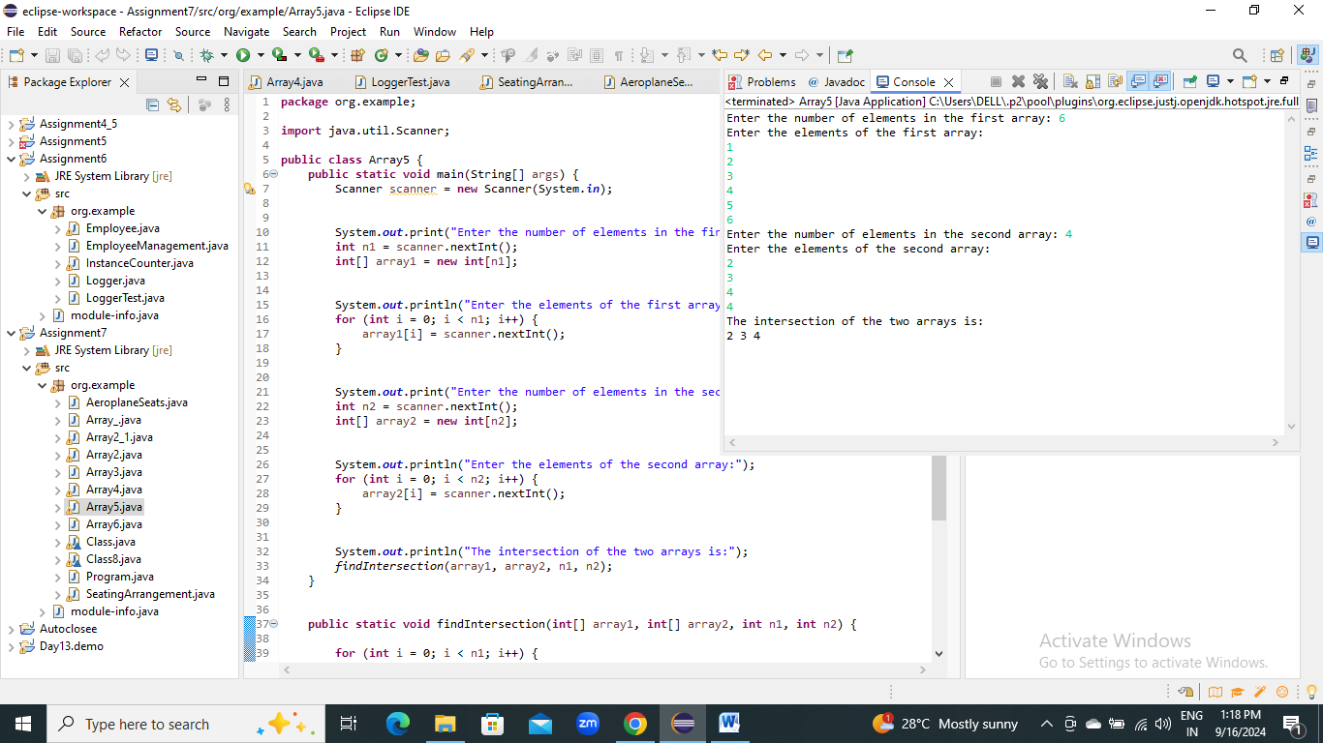

6.Write a program to find the missing number in an array of integers ranging from 1 to N.

**package** org.example;

**public** **class** Array6 {

**public** **static** **void** main(String[] args) {

**int**[] array = {1, 2, 3, 4, 6, 7, 8, 9, 10};

**int** N = 10;

**int** missingNumber = *findMissingNumber*(array, N);

System.***out***.println("The missing number is: " + missingNumber);

}

**public** **static** **int** findMissingNumber(**int**[] array, **int** N) {

**int** expectedSum = N * (N + 1) / 2;

**int** actualSum = 0;

**for** (**int** num : array) {

actualSum += num;

}

**return** expectedSum - actualSum;

}

}

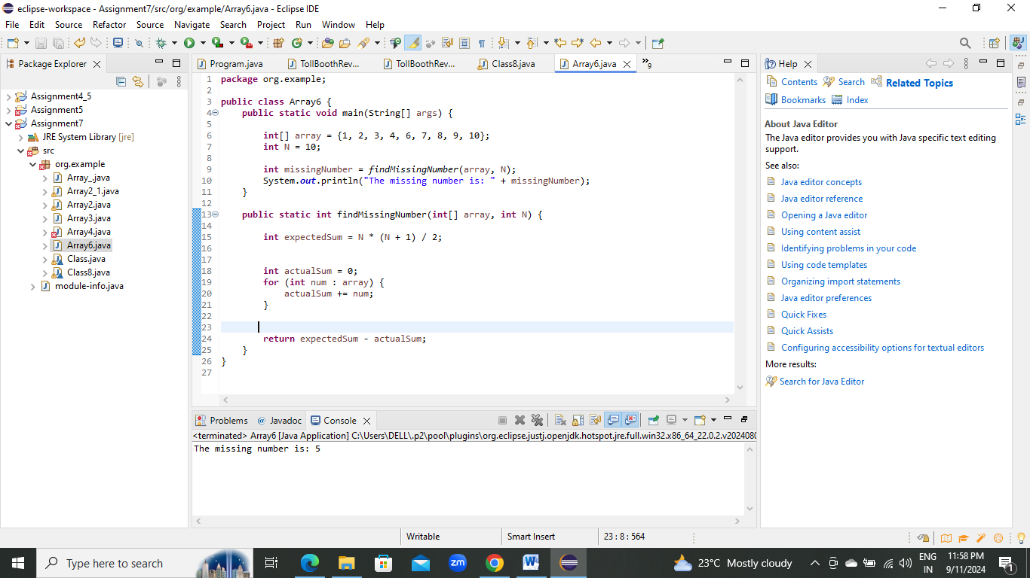

7. declare a single-dimensional array as a field inside a class and instantiate it inside the class constructor. Define methods named acceptRecord and printRecord within the class and test their functionality.

**package** org.example;

**import** java.util.Scanner;

**class** Class {

**private** **int**[] arr;

**public** Class(**int** size) {

arr = **new** **int**[size];

}

**public** **void** acceptRecord() {

Scanner scanner = **new** Scanner(System.***in***);

System.***out***.println("Enter " + arr.length + " integers:");

**for** (**int** i = 0; i < arr.length; i++) {

arr[i] = scanner.nextInt();

}

}

**public** **void** printRecord() {

System.***out***.println("Array elements are:");

**for** (**int** num : arr) {

System.***out***.print(num + " ");

}

System.***out***.println();

}

**public** **static** **void** main(String[] args) {

Class mclass = **new** Class(5);

mclass.acceptRecord();

mclass.printRecord();

}

}

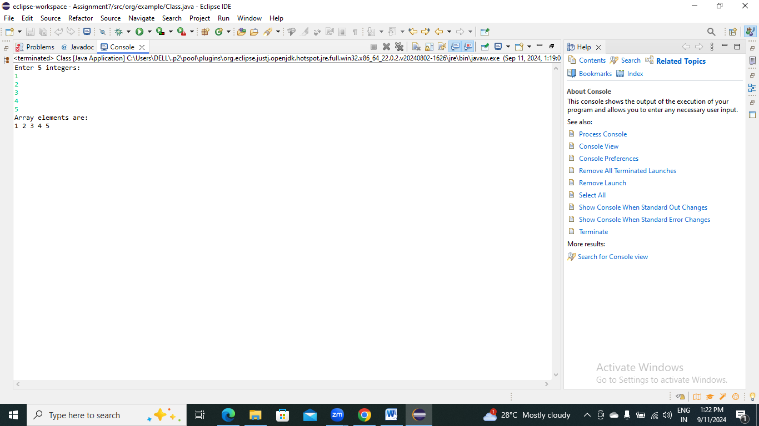

8. Modify the previous assignment to use getter and setter methods instead of acceptRecord and printRecord.

1. **package** org.example;
2. **import** java.util.Scanner;
3. **class** Class8 {
4. **private** **int**[] arr;
6. **public** Class8(**int** size) {
7. arr = **new** **int**[size];
8. }
10. **public** **void** setArray(**int**[] newArray) {
11. **if** (newArray.length == arr.length) {
12. **for** (**int** i = 0; i < arr.length; i++) {
13. arr[i] = newArray[i];
14. }
15. } **else** {
16. System.***out***.println("Array size mismatch.");
17. }
18. }
20. **public** **int**[] getArray() {
21. **return** arr;
22. }
23. **public** **static** **void** main(String[] args) {
25. Class8 myClass = **new** Class8(5);
27. Scanner scanner = **new** Scanner(System.***in***);
28. **int**[] userArray = **new** **int**[5];
29. System.***out***.println("Enter 5 integers:");
31. **for** (**int** i = 0; i < userArray.length; i++) {
32. userArray[i] = scanner.nextInt();
33. }
35. myClass.setArray(userArray);
37. **int**[] resultArray = myClass.getArray();
39. System.***out***.println("Array elements are:");
40. **for** (**int** num : resultArray) {
41. System.***out***.print(num + " ");
42. }
43. }
44. }

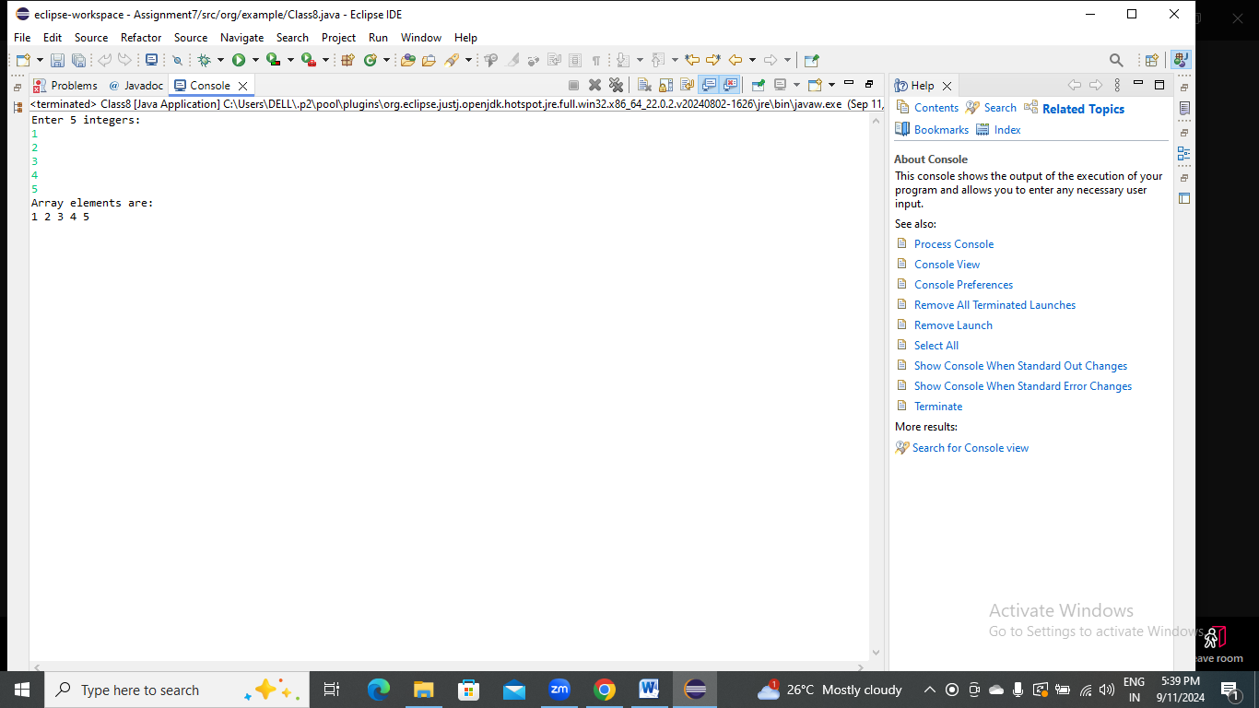

1. You need to implement a system to manage airplane seat assignments. The airplane has seats arranged in rows and columns. Implement functionalities to:

* Initialize the seating arrangement with a given number of rows and columns.
* Book a seat to mark it as occupied.
* Cancel a booking to mark a seat as available.
* Check seat availability to determine if a specific seat is available.
* Display the current seating chart.
* **package** org.example;
* **import** java.util.Scanner;
* **public** **class** SeatingArrangement {
* **private** **char**[][] seats;
* **public** SeatingArrangement(**int** rows, **int** columns) {
* seats = **new** **char**[rows][columns];
* initializeSeats();
* }
* **private** **void** initializeSeats() {
* **for** (**int** i = 0; i < seats.length; i++) {
* **for** (**int** j = 0; j < seats[i].length; j++) {
* seats[i][j] = 'A';
* }
* }
* }
* **public** **boolean** bookSeat(**int** row, **int** col) {
* **if** (isValidSeat(row, col) && seats[row][col] == 'A') {
* seats[row][col] = 'B';
* System.***out***.println("Seat (" + row + ", " + col + ") has been booked.");
* **return** **true**;
* } **else** {
* System.***out***.println("Seat is either already booked or invalid.");
* **return** **false**;
* }
* }
* **public** **boolean** cancelBooking(**int** row, **int** col) {
* **if** (isValidSeat(row, col) && seats[row][col] == 'B') {
* seats[row][col] = 'A';
* System.***out***.println("Booking for seat (" + row + ", " + col + ") has been canceled.");
* **return** **true**;
* } **else** {
* System.***out***.println("Seat is either not booked or invalid.");
* **return** **false**;
* }
* }
* **public** **boolean** checkAvailability(**int** row, **int** col) {
* **if** (isValidSeat(row, col)) {
* **if** (seats[row][col] == 'A') {
* System.***out***.println("Seat (" + row + ", " + col + ") is available.");
* **return** **true**;
* } **else** {
* System.***out***.println("Seat (" + row + ", " + col + ") is not available.");
* **return** **false**;
* }
* } **else** {
* System.***out***.println("Invalid seat coordinates.");
* **return** **false**;
* }
* }
* **public** **void** displaySeatingChart() {
* System.***out***.println("\nCurrent Seating Chart:");
* **for** (**int** i = 0; i < seats.length; i++) {
* **for** (**int** j = 0; j < seats[i].length; j++) {
* System.***out***.print(seats[i][j] + " ");
* }
* System.***out***.println();
* }
* }
* **private** **boolean** isValidSeat(**int** row, **int** col) {
* **return** row >= 0 && row < seats.length && col >= 0 && col < seats[0].length;
* }
* }

**package** org.example;

**import** java.util.Scanner;

**public** **class** AeroplaneSeats {

**public** **static** **void** main(String[] args) {

Scanner scanner = **new** Scanner(System.***in***);

System.***out***.print("Enter the number of rows in the airplane: ");

**int** rows = scanner.nextInt();

System.***out***.print("Enter the number of columns in the airplane: ");

**int** columns = scanner.nextInt();

SeatingArrangement airplaneSeating = **new** SeatingArrangement(rows, columns);

**int** choice;

**do** {

System.***out***.println("\nAirplane Seat Management System");

System.***out***.println("1. Display Seating Chart");

System.***out***.println("2. Book a Seat");

System.***out***.println("3. Cancel a Booking");

System.***out***.println("4. Check Seat Availability");

System.***out***.println("5. Exit");

System.***out***.print("Enter your choice: ");

choice = scanner.nextInt();

**switch** (choice) {

**case** 1:

airplaneSeating.displaySeatingChart();

**break**;

**case** 2:

System.***out***.print("Enter row number to book: ");

**int** rowToBook = scanner.nextInt();

System.***out***.print("Enter column number to book: ");

**int** colToBook = scanner.nextInt();

airplaneSeating.bookSeat(rowToBook, colToBook);

**break**;

**case** 3:

System.***out***.print("Enter row number to cancel booking: ");

**int** rowToCancel = scanner.nextInt();

System.***out***.print("Enter column number to cancel booking: ");

**int** colToCancel = scanner.nextInt();

airplaneSeating.cancelBooking(rowToCancel, colToCancel);

**break**;

**case** 4:

System.***out***.print("Enter row number to check availability: ");

**int** rowToCheck = scanner.nextInt();

System.***out***.print("Enter column number to check availability: ");

**int** colToCheck = scanner.nextInt();

airplaneSeating.checkAvailability(rowToCheck, colToCheck);

**break**;

**case** 5:

System.***out***.println("Exiting the system.");

**break**;

**default**:

System.***out***.println("Invalid choice! Please try again.");

}

} **while** (choice != 5);

scanner.close();

}

}

